Ratings

Pure rating training

Question 01 : What ist he rating of Pepsi Co

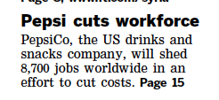

A ) Positive

B ) Negative

C ) Neutral

D ) Ambivalent

Question 02 : What is the rating for Pepsi Co

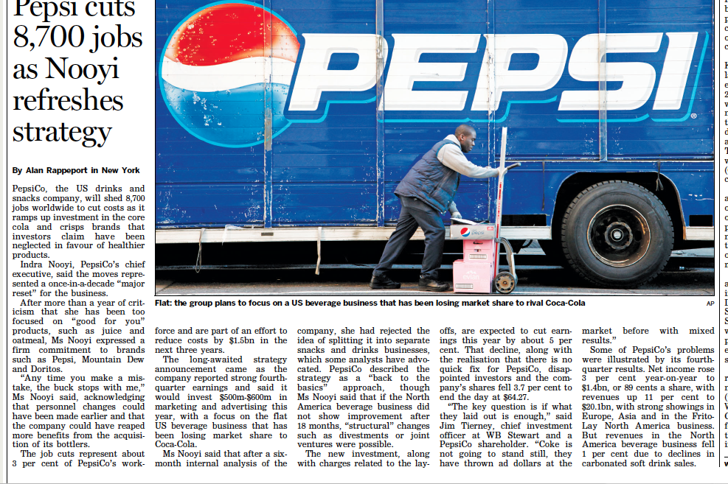A ) Implicit Negative

B ) Implicit Positive

C ) Explicit Negative

D ) Ecxplicit Positive

Question 03 : What is the rating for Pepsi Nooyi (see Question Number 2 )

A ) Positive

B ) Negative

C ) Neutral

Question 04 : What is the rating for Citigroup

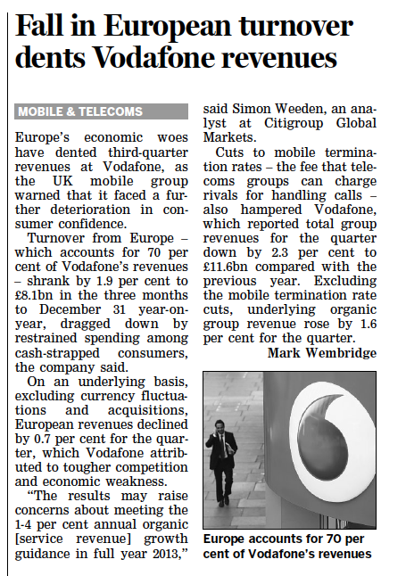

A ) neutral

B ) positive

C ) negative

Question 05 : What ist he rating of Bank of America

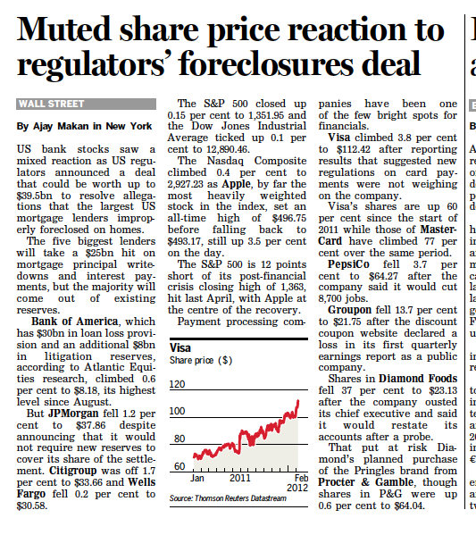

A ) Negative

B ) Positive

C ) Neutral

Question 06 : What is the rating for Diageo

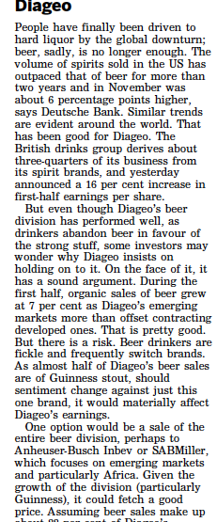

A ) Implicit Negative

B ) Implicit Positive

C ) Explicit Negative

D ) Explicit Positive

E ) Implicit Ambivalent

F ) Explicit Ambivalen